Full-Stack NoSQL Application Proposal

House-Share Bills Tracker

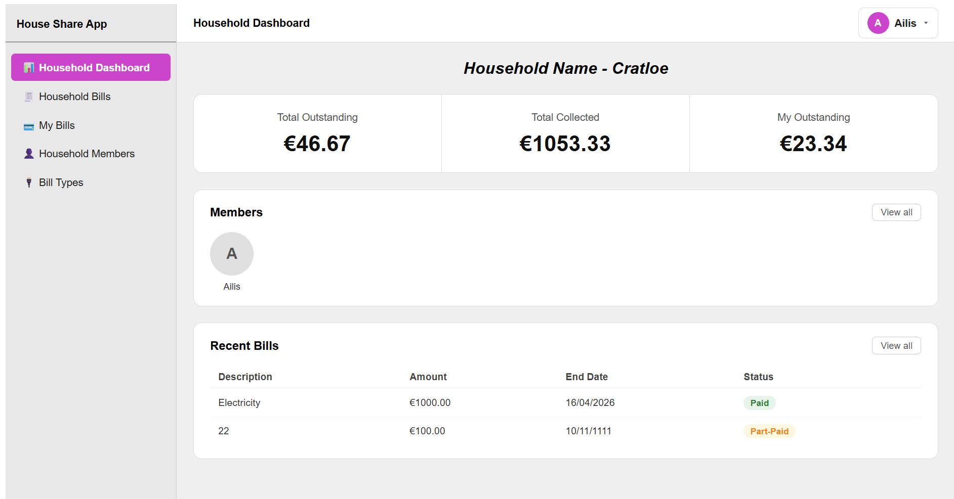
Contents
Full-Stack NoSQL Application Proposal 1
House-Share Bills Tracker 1
1. Architecture Design 3
1.1 Frontend Framework Selection 3
1.2 Backend Technology & API Structure 4
1.3 NoSQL Database Selection 4
1.4 High-Level Architecture Diagram 5
1.5 Data Flow Explanation 5
1.6 Separation of Concerns 5
2. NoSQL Data Model Design 7
2.1 Collections 7
2.2 Example JSON Documents 7
2.3 Embedded vs Referenced Design 9
2.4 Equal Bill Splitting Logic 9
2.5 Partial Payments & Overpayment Prevention 10
3. Technical Defence 11
3.1 Technology Stack Justification 11
3.2 Suitability of NoSQL Model 11
3.3 Business Rule Enforcement 11
3.4 Maintainability Considerations 11
3.5 Future Scalability Planning 12
4. Summary 13

1. Architecture Design

1.1 Frontend Framework Selection
The frontend is developed using Angular.

Justification
- Strong MVC-like structure encourages clean separation of concerns
- Built-in features (routing, forms, HTTP client) reduce dependency overhead
- TypeScript support improves reliability and maintainability
- Ideal for structured enterprise-level applications

Key Views
- Household Dashboard
  - Summary of households total outstanding, total collected, and the members outstanding
  - Displays all members in members household
  - Displays all recent bills
- Bill Detail View
  - Member allocations
  - Payment status and history
- Member View
  - Individual balances across all bills and general payment status
- Administrative View
  - Admin has create buttons on: Bills, Bill Types and Members across webpage
  - Admin has edit and delete buttons on: Bills, Bill Types and Members across webpage
- Add Payment View
- Add Household
  - Adding admin name, email and household name to create new household.

1.2 Backend Technology & API Structure
The backend is built using NestJS.

Justification
- Built on top of Node.js with a modular architecture
- Strong use of controllers, services, and modules
- Built-in support for validation, DTOs, and dependency injection
- Scalable and maintainable for enterprise applications

API Structure (RESTful)
Method | Endpoint | Description
POST | /households | Create household
GET | /households/:id | Get household
POST | /households/:id/members | Add member
POST | /bills | Create bill
GET | /bills/:id | Get bill details
POST | /payments | Add payment
POST | /bill-types | Create bill types
GET | /bill-types/:id | Get bill type details

1.3 NoSQL Database Selection
The system uses MongoDB.

Justification
- Document-based storage fits nested bill structures
- Flexible schema supports evolving requirements
- Efficient for read-heavy operations (bill views)
- Supports horizontal scaling

1.4 High-Level Architecture Diagram
Angular Frontend -> HTTP (Rest API) -> NestJS Backend -> MongoDB Database

1.5 Data Flow Explanation
- User interacts with Angular UI (e.g., creates a bill)
- Angular sends HTTP request via HttpClient to NestJS API
- NestJS:
  - Validates request using DTOs
  - Applies business logic in services
  - Interacts with MongoDB via models/schemas
- Database stores/retrieves data
- Response returned to frontend
- UI updates automatically

1.6 Separation of Concerns

Frontend (Angular)
- Components → UI
- Services → API calls
- Models → Data typing

Backend (NestJS)
- Controllers → Handle requests
- Services → Business logic
- Modules → Feature organisation

Database
- Stores persistent application data

Scalability Considerations
- Stateless APIs → easy horizontal scaling
- Modular NestJS architecture
- MongoDB clustering for large datasets

2. NoSQL Data Model Design

2.1 Collections
- households
- members
- bills
- bill-types

2.2 Example JSON Documents

Household
{
"_id": "house1",
"name": "12 Oak House",
"members": [
"member1",
"member2",
"member3",
"member4"
],
}

Member
{
"_id": "member1",
"name": "Alice",
"householdId": "house1",
"role": "admin"
}

Bill
{
"_id": "bill1",
"householdId": "house1",
"billTypeID": "Electricity",
"totalAmount": 200,
“startDate”: 02/04/2026,
“endDate”: 06/04/2026,
“isClosed”: false
}

Bill Type
{
"_id": "billtype1",
"name": "Electricity",
"householdId": "house1"
}

Allocation
{
“_id”: “allocation1”,
“billID”: bill1,
“memberID”: Alice,
“amountPaid”: 100,
“amountOwed”: 100,
“status”: paid
}

Payments
{
“_id”: payment1,
“allocationID”: allocation1,
“memberID”: Alice,
“amount”: 100,
“paidAt”: 03/04/2026
}

2.3 Embedded vs Referenced Design

Embedded
- Allocations stored inside bills
- Payments stored inside allocations

Reason
- Faster reads for bill detail view
- Reduces database queries
- Matches natural data hierarchy

Referenced
- Members referenced via IDs

2.4 Equal Bill Splitting Logic
When a bill is created:
owed_per_member = total_amount / number_of_members

Rounding Strategy
- Round to 2 decimal places
- Adjust final member allocation to ensure exact total

2.5 Partial Payments & Overpayment Prevention

Logic
- Update:
  - paid
  - outstanding = owed - paid

Validation Rule
payment_amount ≤ outstanding
If violated → reject request in backend service

3. Technical Defence

3.1 Technology Stack Justification
Layer | Technology | Reason
Frontend | Angular | Structured, scalable UI
Backend | NestJS | Modular, enterprise-ready
Database | MongoDB | Flexible NoSQL storage

3.2 Suitability of NoSQL Model
- Nested allocations suit document model
- High read performance for dashboards
- Flexible schema for future features

3.3 Business Rule Enforcement
Handled in NestJS service layer:
- Ensure allocations sum to total
- Prevent overpayment
- Enforce household membership
- Automatically update statuses

3.4 Maintainability Considerations
- Modular NestJS architecture
- Angular service-based API handling
- Strong typing via TypeScript
- Reusable logic for allocations/payments

3.5 Future Scalability Planning
- Add authentication (JWT)
- Role-based permissions
- Real-time updates (WebSockets)
- Support unequal bill splitting
- Mobile app integration

4. Summary
This solution delivers:
- A scalable Angular + NestJS architecture
- Efficient MongoDB data modelling
- Strong enforcement of business rules
- Clean separation of concerns
- A future-proof design for expansion

